



DEPARTMENT OF COMPUTER SCIENCE

THEORY OF COMPUTATION
LAB 1
STRING MATCHING & COMPARISION

Submitted by: |  | Submitted to: | Signature:
Prasoon Raj Shakya  Roll No.: 024BSCIT028  4th Sem - Section B |  | Mr. Ganesh Dhami  Department of Computer Science  St. Xavier’s College

Source Code
import os
os.system("cls")

symbol_set = input("Enter symbol set: ")
string = input("Enter string: ")

for ch in string:
found = False
for sym in symbol_set:
if ch == sym:
found = True
break
if not found:
print("Invalid String")
exit()
print("Valid String")

Output/Observations
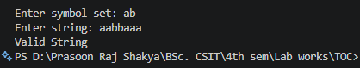
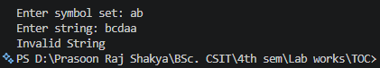

Conclusion
The Python program successfully verifies whether a given string belongs to a specified alphabet set by ensuring all characters are part of the defined symbol set. This demonstrates the fundamental principle of string acceptance in formal languages and provides a basic implementation of deterministic finite automata behavior in software form.

Source Code
def length(str):
i=0
for ch in str:
i+=1
return i

s1 = input("Enter a string: ")
s2 = input("Enter another string: ")
i=0
if s1 == s2:
print("improper prefix")
elif length(s2)>length(s1):
print("not a prefix")
else:
prefix = True
for i in range(length(s2)):
if s1[i] != s2[i]:
prefix = False
break
if prefix:
print("Proper Prefix")
else:
print("Not a Prefix")

Output/Observations
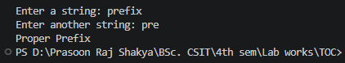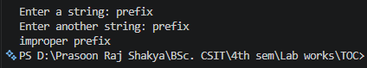
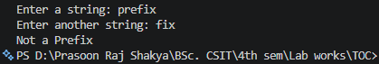

Conclusion
This program successfully determines whether one string is a proper prefix, improper prefix, or not a prefix of another string. It uses a user-defined function to find string lengths and performs character-by-character comparison to verify the prefix relationship. Through this lab, the concepts of prefix checking were understood and implemented effectively in Python.

Source Code
def length(str):
i = 0
for ch in str:
i += 1
return i

s1 = input("Enter a string: ")
s2 = input("Enter another string: ")

if s1 == s2:
print("improper suffix")
elif length(s2) > length(s1):
print("Not a suffix")
else:
suffix = True
for i in range(1, length(s2)+1):
if s1[- i] != s2[-i]:
suffix = False
break
if suffix:
print("Proper Suffix")
else:
print("Not a Suffix")
Output/Observations
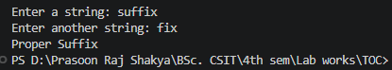
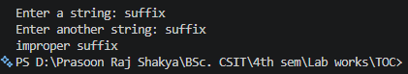
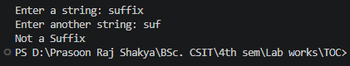

Conclusion
This program successfully determines whether one string is a proper suffix, improper suffix, or not a suffix of another string. It uses a user-defined function to find string lengths and performs character-by-character comparison from the end of the strings to verify the suffix relationship. Through this lab, the concepts of suffix checking were understood and implemented effectively in Python.

Source Code
def length(s):
count = 0
for ch in s:
count += 1
return count

s1 = input("Enter a string: ")
s2 = input("Enter another string: ")
substring = False
for i in range(length(s1) - length(s2) + 1):
match = True
for j in range(length(s2)):
if s1[i + j] != s2[j]:
match = False
break
if match:
substring = True
break
if substring:
print("Substring")
else:
print("Not a Substring")
Output/Observations
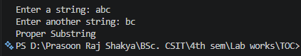
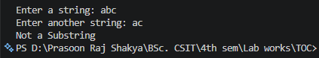
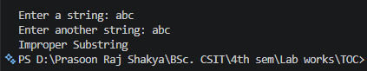

Conclusion
This program successfully determines whether one string is a substring of another string. It uses a user-defined function to find string lengths and performs character-by-character comparison at different positions within the main string to verify the substring relationship. Through this lab, the concepts of substring searching, nested loops, and string comparison were understood and implemented effectively in Python.

